**Synopsis Report**

**on**

**SWARM PROPELLED AUTONOMOUS CELESTIAL EXPLORATORY ROBOTS**

***Submitted in partial fulfilment of the***

***Requirements for the award of the degree***

***of***

BACHELORS OF ENGINEERING

in

MECHATRONICS ENGINEERING

**Submitted By: - Faculty Supervisor: -**

Preetinder Singh Mr. Inderpreet Singh  
19BEM1032



**UNIVERSITY INSTITUTE OF ENGINEERING**

**CHANDIGARH UNIVERSITY**

**GHARUAN, MOHALI, PUNJAB, INDIA-140413**

**2019**

|  |  |  |
| --- | --- | --- |
| **INDEX** | | |
| **Sr. No** | **Content** | **Pg. No** |
| **1** | **CANDIDATE’S DECLARATION** | **2** |
| **2** | **INTRODUCTION** | **3** |
| **3** | **LITERATURE REVIEW** | **3 – 4** |
| **4** | **METHODOLOGY**   * **OBJECTIVE** * **STEPS INVOLVED** | **4 – 6** |
| **5** | **BLOCK DIAGRAM** | **6** |
| **6** | **REQUIRED ELEMENTS & DESCRIPTION OF PARTS** | **6 – 8** |
| **7** | **Approximate Cost and Total Cost** | **8** |
| **8** | **WORK PLAN AND FUTURE SCOPE** | **9-13** |
| **9** | **ACKNOWLEDGEMENT** | **14** |
| **10** | **REFERENCE** | **15** |

|  |  |  |
| --- | --- | --- |
|  |  |  |
|  |  |  |
|  |  |  |
|  |  |  |

**CHANDIGARH UNIVERSITY, GHARUAN, MOHALI**

**CANDIDATE'S DECLARATION**

I “Preetinder Singh'' hereby declare that the work embodied in this synopsis entitled **“**SWARM PROPELLED AUTONOMOUS CELESTIAL EXPLORATORY ROBOTS**”** is in partial fulfilment of requirements for the award of the degree of B.E (MECHATRONICS ENGINEERING) at **CHANDIGARH UNIVERSITY GHARUAN, MOHALI.** The work which is being presented in this synopsis submitted to the **Department of Mechatronics Engineering** is an authentic record of a bonafide piece of work.

Signature

(Preetinder Singh)

Supervisor Signature

(Name and Designation)

**INTRODUCTION**

Our project is swarm autonomous robots that can run on plains, underwater and overwater, and climb the walls also. This robot can do so with the help of a brushless electric duct motor propeller. For wall climbing, the robot pushes the air away from the wall, by Newton's third law which states that every action has an equal and opposite reaction, the robot feels the equal push and generates the normal reaction which in turn provides the required frictional force to climb the wall. In water, with the help of a propeller, we can adjust the depth of the robot. Therefore, the robot can swim underwater as well as above water. Wall climbing is a special ability of the robot. It makes the robot suitable for many applications. For example, cleaning the windows of multi-storey buildings, doing research on naturally formed narrow tunnels, examining sewerage tunnels and researching in different areas of other planets etc.

**METHODOLOGY**

**Objective:**

The main purpose of the project is to make a robot that can reach different places on other planets where it is usually impossible for currently existing rovers to reach. For example, Going inside any deep trench or climbing up on the steep mountains. Due to the movement of tectonic plates, the surface of any solid planet can rise or fall. By these activities, a lot of information hidden under the surface uncovers itself in the form of steep mountains and deep trenches. If we somehow can make any method to reach different layers of distant planets and gather this information, then it would be a huge advantage to mankind. We can gather information about any life present; we can gather information about different climate conditions and many more things. So the main purpose of our project is to make a robot that can gather information from mountains and trenches. In this way, we are trying to open new possibilities in the field of research. Apart from that, because of the different features of our robot, it can be used for other purposes also like washing the windows, studying narrow caves, or helping firefighters by bringing the pipe to a specific room of the building etc.

**Steps Involved algorithm**

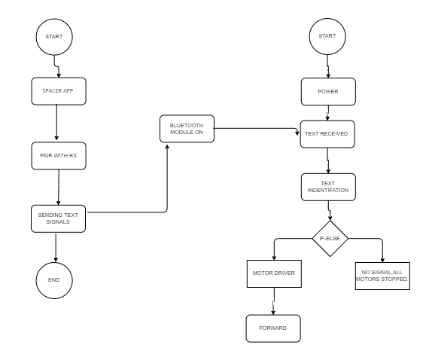

Block Diagram

### SYSTEM DESIGN

#### *A. Mechanical design*

Figure 1 shows different views of the general struc  
ture of the generatively designed body of our project which we indeed made for 3D printing. The purpose of this design is to make sure that the weight of the robot body is the least possible but maintaining a good amount of durability and factor of safety. By using aluminium as a material we can easily do the weight reduction. as 3d printing is still new to industry and costs a lot so it was practically impossible for students like us to afford it due to which we made our body out of sun board for making our first prototype and proof of concept model. The main body of the robot is able to carry, all the electronic components including propeller with 2600Kv brushless motor and it’s Esc.because we are using li-ion cells instead of li- polymer battery pack the weight of our battery was alone 1.5Kg alone, hence we decided to keep it outside the body for our 1st prototype as shown in fig.4.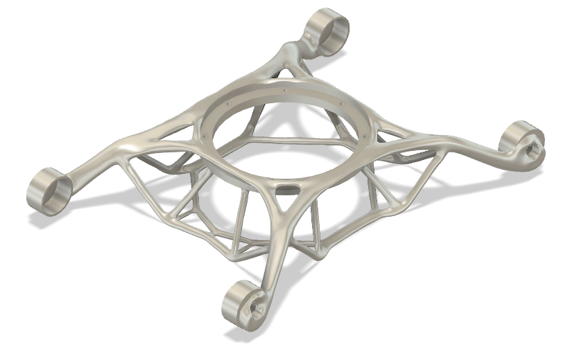

Figure 1: 3-D design of the interior body

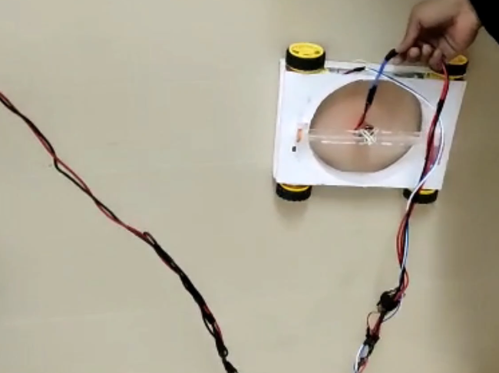

Figure 4: Actual robot project version 0 while climbing the wall.

**DESCRIPTION OF PARTS:**

1. **Arduino/Teensy 3.6 board:** We are using Arduino nano for the project as it is lightweight and covers less space. The Arduino nano board is based on the ATmega328 microcontroller. The teensy board can also be used for this project.
2. **EDF with BLDC motor:** A 2600 kV BrushLess DC motor is used for moving the electric duct fan of the 7-inch propeller. It provides the required force for the robot to stay on the wall and defy gravity.
3. **Hobbywing 30A ESC:** Electronic speed control (ESC) controls and regulates the speed of the electric motors. Therefore it is used to control the brushless motor of the robot.
4. **DC BO high torque motor:** Four DC high torque motors are used for robot tyres. These motors can reach a maximum speed of 30 RPM. These motors provide optimal size, power and response time. These features make the motors ideal for this project.
5. **Power distribution module:** As the name suggests, it is used for the power distribution among the motors used in the robot.
6. **Motor Driver:** MOSFET based L298n motor drive is used for the motors moving the tyres of the robot. It is lightweight and compact. These features are proven very useful for our project.
7. **Ion- Lithium Battery pack:**  we are usinga lithium-Ion battery pack as the power supply for the robot prototype. It provides 11.4 V of maximum voltage and 10.4 A of maximum current.
8. **Bluetooth module:** Bluetooth module is used for communication between robot prototype and controller. It provides wireless serial communication. It is also used for master-slave communication.
9. **7-inch propellor with fastening assembly:** Propellor helps the robot in climbing the walls and moving underwater and overwater. We used a 7-inch propellor which is fastened to the robot using a simply supported beam assembly.
10. **CONNECTING WIRES:** Wires are a necessary part of every system and they are used for electrical connections between various electronic devices.
11. **RF module:** For this project,nRF2L01 2.4 GHz Radio Frequency module can be used for communication between robot and controller.

**Approximate Cost of project:**

Brushless motor 2600kv 1 X 900 = 900

Bo motors dc 4 X 80 = 320

Tyres 4 X 60 = 240

Wires as per requirement 100

Li ion battery pack 11.4 volt 10.4 amp 1500

Esc 30 amp 350

Arduino nano 300

Bluetooth module 250

L298n motor driver 240

:Sunboard for body formation 400

Switches and connectors 50

**TOTAL COST Rs.4650**

**Coding required for SPACER**

#include <Servo.h>

#include <SoftwareSerial.h>

Servo myservo;

int bluetoothTx = 10; // bluetooth tx to 10 pin

int bluetoothRx = 11; // bluetooth rx to 11 pin

SoftwareSerial bluetooth(bluetoothTx, bluetoothRx);

char t;

void setup() {

myservo.attach(9); // attach servo signal wire to pin 9

pinMode(2,OUTPUT); //left motors forward

pinMode(3,OUTPUT); //left motors reverse

pinMode(4,OUTPUT); //right motors forward

pinMode(5,OUTPUT);//right motors reverse

pinMode(6,OUTPUT);

pinMode(13,OUTPUT); //Led

//Setup usb serial connection to computer

Serial.begin(9600);

//Setup Bluetooth serial connection to android

bluetooth.begin(9600);

}

void loop() {

//Read from bluetooth and write to usb serial

if(bluetooth.available()> 0 ) // receive number from bluetooth

{

int servopos = bluetooth.read(); // save the received number to servopos

Serial.println(servopos); // serial print servopos current number received from bluetooth

myservo.write(servopos); // roate the servo the angle received from the android app

}

if(Serial.available()){

t = Serial.read();

Serial.println(t);

}

if(t == '1'){

//move forward(all motors rotate in forward direction)

digitalWrite(2,HIGH);

digitalWrite(3,LOW);

digitalWrite(5,LOW);

digitalWrite(4,HIGH);

}

else if(t == '2'){ //move reverse (all motors rotate in reverse direction)

digitalWrite(2,LOW);

digitalWrite(4,LOW);

digitalWrite(3,LOW);

digitalWrite(5,LOW);

}

else if(t == '3'){ //move reverse (all motors rotate in reverse direction)

digitalWrite(3,HIGH);

digitalWrite(2,LOW);

digitalWrite(5,HIGH);

digitalWrite(4,LOW);

}

else if(t == '4'){ //move reverse (all motors rotate in reverse direction)

digitalWrite(3,LOW);

digitalWrite(2,LOW);

digitalWrite(4,LOW);

digitalWrite(5,LOW);

}

else if(t == '5'){ //turn right (left side motors rotate in forward direction, right side motors doesn't rotate)

digitalWrite(3,HIGH);

digitalWrite(2,LOW);

digitalWrite(5,LOW);

digitalWrite(4,HIGH);

}

else if(t == '6'){ //turn left (right side motors rotate in forward direction, left side motors doesn't rotate)

digitalWrite(2,LOW);

digitalWrite(3,LOW);

digitalWrite(4,LOW);

digitalWrite(5,LOW);

}

else if(t == '7'){ //turn left (right side motors rotate in forward direction, left side motors doesn't rotate)

digitalWrite(5,HIGH);

digitalWrite(4,LOW);

digitalWrite(3,LOW);

digitalWrite(2,HIGH);

}

else if(t == '8'){ //turn left (right side motors rotate in forward direction, left side motors doesn't rotate)

digitalWrite(4,LOW);

digitalWrite(5,LOW);

digitalWrite(3,LOW);

digitalWrite(2,LOW);

}

// waits 15ms for the servo to reach the position

else if(t == 'A'){ //STOP (all motors stop)

digitalWrite(6,HIGH);

digitalWrite(13,HIGH);

delay(100);

}

else if(t == 'B'){ //STOP (all motors stop)

digitalWrite(6,LOW);

digitalWrite(13,LOW);

}

}

**Application of SPACER which is officially made and designed by us:**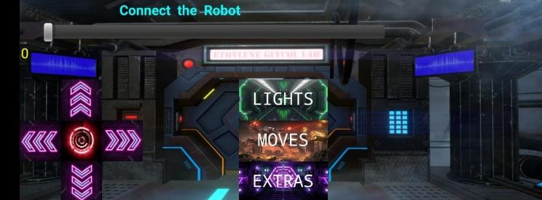

**Work plan and work distribution:**

Every team member has equally participated and contributed towards the making and implementation of this project toward success.

Preetinder Singh:

*Idea generation

*Name generation

* Design & Build

*Feature enhancement

*Physical assembly

* PPT formation

* Research Paper

Orsu Vinay:

*Idea generation

*Name generation

* Design & Build

*Feature enhancement

*Physical assembly

* PPT formation

* Research Paper

Pacha Bhanuprasad:

*Idea generation

*Name generation

* Design & Build

*Feature enhancement

* Project Report

* Project Synopsis

*PPT modification

Ajay Kumar:

*Idea generation

*Name generation

* Design & Build

*Feature enhancement

* Project Report

* Project Synopsis

* PPT modification

Sankhyadip paul:

*Idea generation

*Name generation

* Design & Build

*Feature enhancement

* Physical assembly

* PPT modification

* Research Paper

**FUTURE SCOPE and modifications possible:**

As we all know, the whole world has faced the covid-19 situation. So it took some time for us to meet and give the project its final touch. Some team members who are nearby the university tried to collectively work on the physical model and others interacted through online mode. Due to the covid-19 situation, we used the material available nearby us for the body of the robot. In the future, we will try to increase. Also, we will try to add a robot hand to our project so that it can use different tools for different purposes. We are also looking forward to adding machine learning to our project.

**ACKNOWLEDGEMENT**

It gives me the privilege to complete this mid-semester project. This is the only page where we have the opportunity to express our emotions and gratitude. It is a great pleasure in expressing sincere and deep gratitude towards my supervisor and guides Mr Inderpreet Singh for her valuable suggestions, guidance, and constant support throughout the completion of this project named “Swarm Propelled Autonomous Celestial Exploratory Robots''. I am really very thankful to Chandigarh University for providing me with such a great opportunity to make such a wonderful project which can solve real-life problems and extremely valuable hands-on experience along with crucial soft skills such as working in a team, communication skills, and much more. I also offer my most sincere thanks to every team member of our group who was working rigorously on this project and staff members of the Mechatronics Department, University Institute of Engineering, Chandigarh University for cooperation provided by them in every possible way.

9th December, 2021 Preetinder Singh

**REFERENCES:**

1. Maki K. Habib, “Omni Directional Robot That Can Climb A Wall”, 6th Intl Conf. on Mechatronic Technology, Kitakyushu, Japan, 2002.

2. M. Murphy, M. Sitti, “Waalbot: An Agile SemiAutonomous Wall Climbing Robot”

3. Chun- Hung Chen, Vijay Kumar, “Motion Planning of Walking Robots in Environment with Uncertainty”

4. C. Menon, M. Murphy, M. Sitti, “Gecko Inspired Surface Climbing Robots” IEEE Intl Conf. on Robotics and Biomimetics (ROBIO), Shenyang, China, 2004.

5. Tomoshisa OHMORI, Peng Chen, “Walking Control method for Quadruped Robot by Genetic Algorithms”, 6th Intl Conf. on Mechatronic Technology, Kitakyushu, Japan, 2002.

6. L. Briones, P. Bustamante, and M. Serna (1994) ROBICEN: A wall-climbing pneumatic robot for inspection in nuclear power plants. Robotics and Computer-Integrated Manufacturing 11, 287-292.

7. Z. Yanzeng, S. Hao, and W. Yan (1999) Wall-climbing robot with negative pressure sucker used for cleaning work. High Technology Letters 5, 85-88

8. L. Shuliang, Z. Yanzheng, G. Xueshan, X. Dianguo, Wang Yan (2000) A wall-climbing robot with magnetic crawlers for sand-blasting. Spray-painting